 | 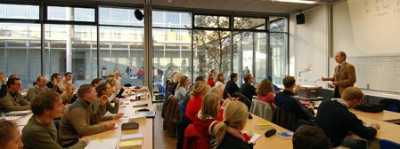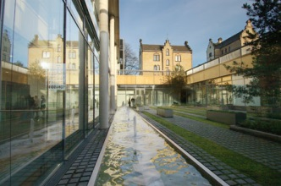
 | Application Form BLOCK WEEK Seminar
Date of block week:  (SS or WS) | Click here to add text.
Lecturer: | Titel: Click here to add text.
 | First name: Click here to add text. |  | Surname: Click here to add text.
Home university: | University: Click here to add text.
 | Faculty/Dept.: Click here to add text.
 | Address: Click here to add text.
 | Website: Click here to add text.
Title of seminar: | Click here to add text.
Type of seminar*:  (Please select one type) | ☐ International Block Week  ☐ National Block Week  ☐ Excursion | Language of instruction: |  | ☐ German  ☐ English  ☐ Others:
Contents/description of the seminar:
Click here to add text.

Important notes:
(e.g. language of instruction or specifics of the course)
Click here to add text.

* In case of doubt, the classification of the “type of seminar” will be made by the dean of studies.

Your block week seminar in detail

Target group: |  | Click here to add text.
Maximum number of  participants: |  | Click here to add text.
Start and time schedule: |  | Monday to Thursday: 9 am to 4 pm  Friday: 9 am to 1 pm
Number of required rooms: |  | 1 seminar room is scheduled for the registered group in the required size!
Specifics of the room(s): |  | Click here to add text.
 |  | Please ask for additional rooms only if they are absolutely needed!
Media equipment:
(all regular seminar rooms are equipped with computer, data projector and overhead projector)
☐ Metaplan board ** |  |  | ☐ Flip Chart **
☐ Presentation equipment |  |  | ☐ Speaker’s desk (depending on availability)
☐ Television Set |  |  | ☐ Video/TV (depending on availability)
☐ Video camera with microphone (depending on availability) |  |  | ☐ DVD (depending on availability)
☐ White Board |  |  | ☐ Black Board
Other  Requirements: | Click here to add text.

** in case more than one board is needed the availability is depending on the resources of the university.
Deviations are possible.

Please return your completed form
via e-mail to the International Faculty Office:
s.kohlsaat@hs-osnabrueck.de

